Assembly 2

Instruction processing
The fetch-decode-execute cycle is the series of steps that a computer carries out when it runs a program.
- We first have to fetch an instruction from memory, and place it into the instruction register
- Once in the instruction register, it is decoded to determine what needs to be done next.
- If a memory value (operand) is involved in the operation, it is retrieved and placed into the memory buffer register.
- With everything in place, the instruction is executed.
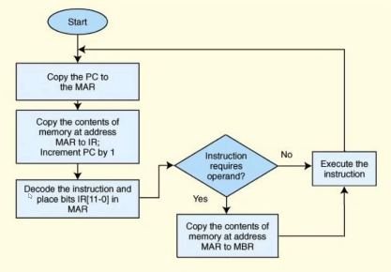

All computers provide a way of interrupting the fetch-decode-execute cycle.
- Interrupts occur when:
  - A user break (e.g., Control + Shift + C) is issued.
  - I/O is requested by the user or a program.
  - A critical error occurs
- Interrupts can be caused bby hardware or software.
  - Software interrupts are also called traps.
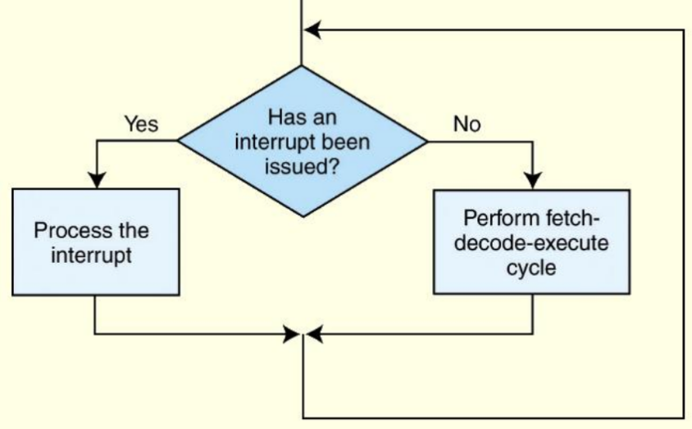
Interrupt processing involves adding another step to the fetch-decode-execute cycle as shown on the next slide.
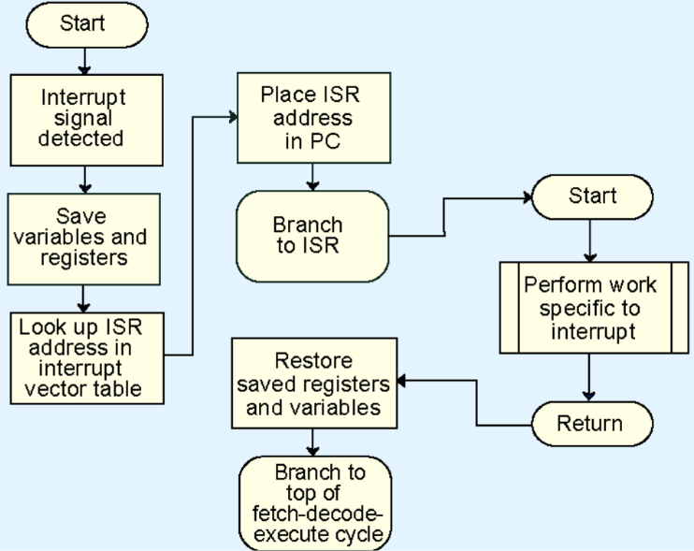
This is a flowchart of how the interrupt is handled in the CPU

For general purpose systems, it is common to disable all interrupts during the time in which an interrupt is being processed.
Typically this is achieved by setting a bit in the flags register.
- Interrupts that are ignored in this case are called maskable.
- Nonmaskable interrupts are those that must be processed in order to keep the system in a stable condition.

A simple program
Consider the simple MARIE program given below. We show a set of mnemonic instructions stored at addresses 100 – 106:
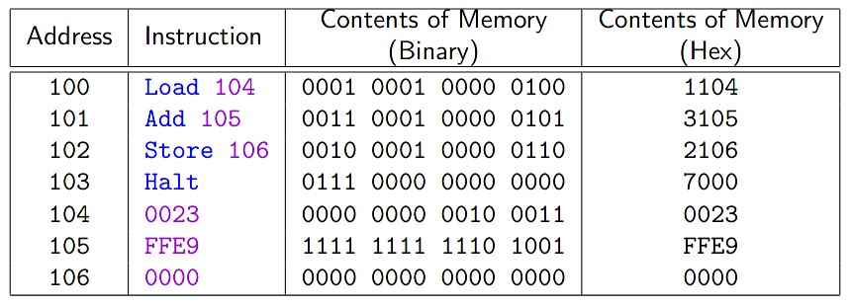
How does the computer handle the instructions?
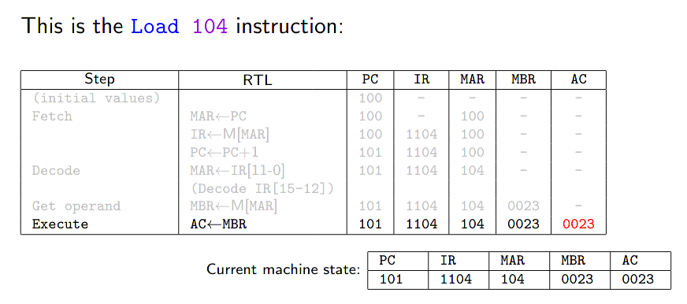

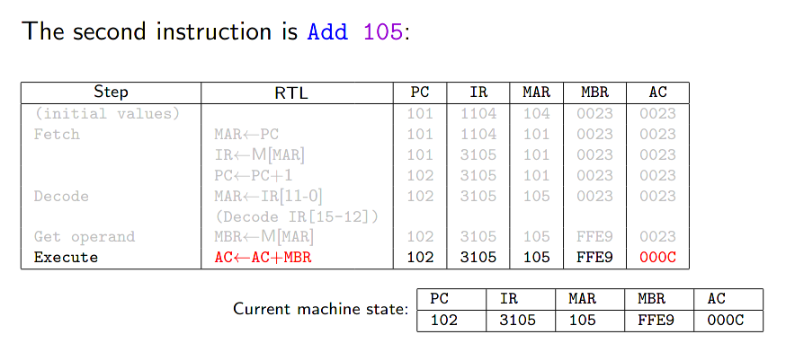

Extended isa for marie
MARIE’s extended instruction set contains the following indirect address mode instructions:
- AddI: Add value at address in address specified
- JnS: Jump to subroutine at specified address.
- JumpI: Jump to the address in the address specified

It is also helpful to have:
- Clear: zero the accumulator
The AddI instruction specifies the address of the address of the operand to be added.
The following RTL tells us what is happening at the register level:
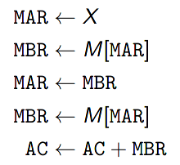

Another helpful programming tool is the use of subroutines.
- Jump-and-store, JnS, gives us limited functionality for this.
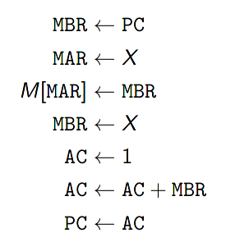
Below is the RTL for JnS

JnS operates by storing the current PC value in the first address of the routine itself, then continuing the instruction following that (by storing the entry address +1 in the PC)
- To return from the subroutine, JumpI to the subroutine name.
e.g.:
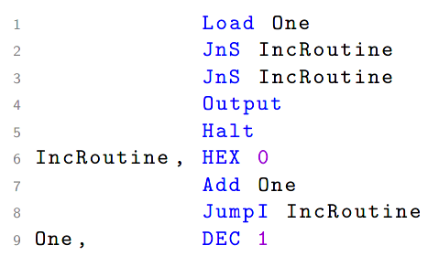

Our last helpful instruction is the Clear instruction.
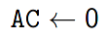

Assemblers
Mnemonic instructions, such as Load 104, are easy for humans to write and understand, but they are impossible for computers to understand.
Assemblers translate instructionjs that are comprehensible to humans into the machine language that is comprehensible to computers
- NB : the distinction between an assembler and a compiler is that in assembly, there is a one-to-one correspondence between mnemonic instruction and its machine code. With compilers, this is usually not the case.
Assemblers create an object program file from mnemonic source code in two passes:
1st pass The assembler assembles as much of the program as it can, while it builds a symbol table that contains memory references for all symbols in the program.
2nd pass The instructions are completed using the values from the symbol table.

